Milestone 5: 23/1/21 – 7/2/21

This Milestone will prioritise building the rest of the game, starting with the first level. Work on the rest of the Hunter boss fight shall come later.

|  |  |  |
| --- | --- | --- |
| Goal | Description | To Deliver |
| Learn how to program a dialogue system | The player will be able to talk to the Prisoner and the Helper at various points of the game. They will also have different things to say depending on the players progress in the game. Learn how to program this system. | Possess the knowledge needed to implement the dialogue system. |
| Implement a dialogue system for the Prisoner in the first level | The Prisoner will have different things to say depending on the players progress. Implement this dialogue system. | The player should be able to stand in front of the Prisoner, press a “interact” button, and proceed through the Prisoner’s dialogue. The Prisoner’s dialogue should be influenced by a Game Manager object that tells the Prisoner how many times the player has died. |
| Design the First level | While the basic design has been made, the specific obstacle within it have not been. We know that we want the player to learn to attack, jump and talk in the first area. Design how these will be taught. | A basic plan for how to teach the player the basic skills of attacking, jumping and talking. |
| Implement the design of the first level. | This may require multiple steps, as it may include developing new objects and structures for the level. | A completed first implementation of the first level. |
| Hold a meeting to discuss the future of the art direction | Discuss as a team what should be prioritised next. | Hold the meeting. |

A while has passed since this sprint, but from memory (and from looking at the game) it seems that all of these were done. Time for the next sprint!

Milestone 6: 2/7/2021 – 9/7/2021

This sprint will be a bit shorter, so that the team can get a good grasp of what needs to take priority. Also Liam will be going through a lot of life-changes at the end, so it’s better to keep things small for now.

|  |  |  |
| --- | --- | --- |
| Goal | Description | To Deliver |
| Hold “getting back to it” meeting. | Hold the meeting. | Hold the meeting. |
| Get to know the project again | It’s been a while. Use the other goals as a chance to remember how everything is done. |  |
| Start designing enemy types | There should be some different enemy types to help teach the player how to use their skills. Design them. | At least 1 enemy type fully conceptualised. Possibly work towards making them. |
| Implement room #1 | Room #1 is pretty barren by design, so should be an easy beginning point for getting back into it. | Room #1 is a corridor. The Helper is there and gives some dialogue. The player should also have a tutorial on how to attack (no more complicated than Hollow Knight). |
|  |  |  |

Level 1 ideas:

* Rock at the end of the room – break to continue, teaching player to attack.
  + Attack 3 times to destroy.
  + Each attack damages the rock a little – not cracked -> cracked -> very cracked -> breaks apart, spawning rocks and apply force to them.
  + Sprite list:
    - Not cracked
    - Cracked a little
    - Cracked a lot (and looks like it’s made up of distinct parts/or not lol)
    - Small rocks (approx. 3, could all be identical or just slightly different.

Enemy ideas:

* Enemies who rush you:
  + They run towards you when they see you.
  + Design: The Heartless, but with tattered cloaks caked in blood.

First Level:

* Idea:
  + Introductory
  + Teaches the player how to play
  + Some smaller challenges
  + Tutorial character – teaches you how to play while adding personality
* Obstacle ideas:
  + Platforming – not many platforming abilities, should not be the main focus?
  + Shade-gate (Hollow Knight) – a gate that stops progress unless you dash through them.
  + Enemies – teach you how to block/parry/dash/jump over obstacles

Idea:

* The game is a cycle from the beginning of the game to the end – boss kills you, you begin again beneath the arena, start over.
* The characters mention this right from the beginning – you’ve done this before
* “Back again so soon?”
* Characters are aware of how many times you’ve died (e.g. through a singleton script that takes note of all the things you’ve done in the game)

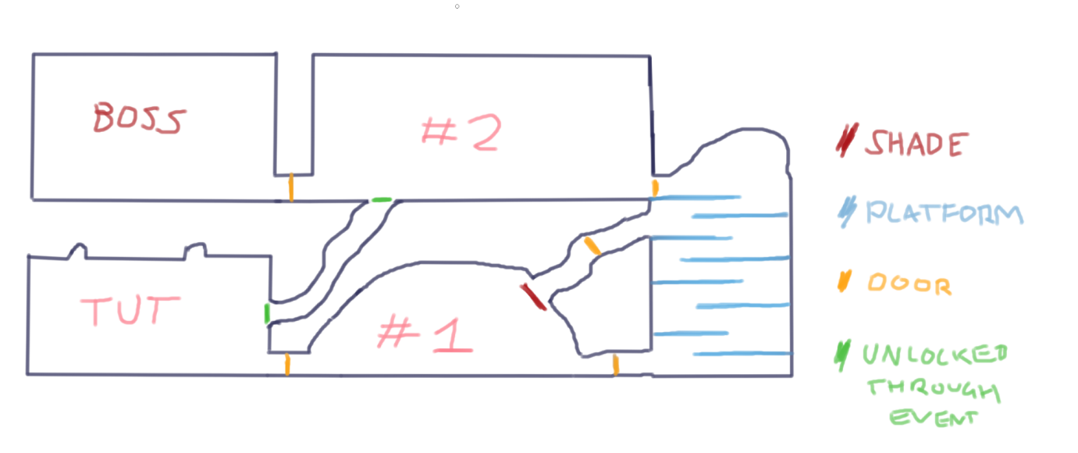

Tut = player spawn. Meets the Prisoner

#1 = Player meets the Helper

Then platforming/fighting section.

#2 = just outside the throne room. Within the palace

Boss = throne room